2024/09/02 Hora 09:23

2024/09/02 Hora 09:23

Nivel_del_combustible

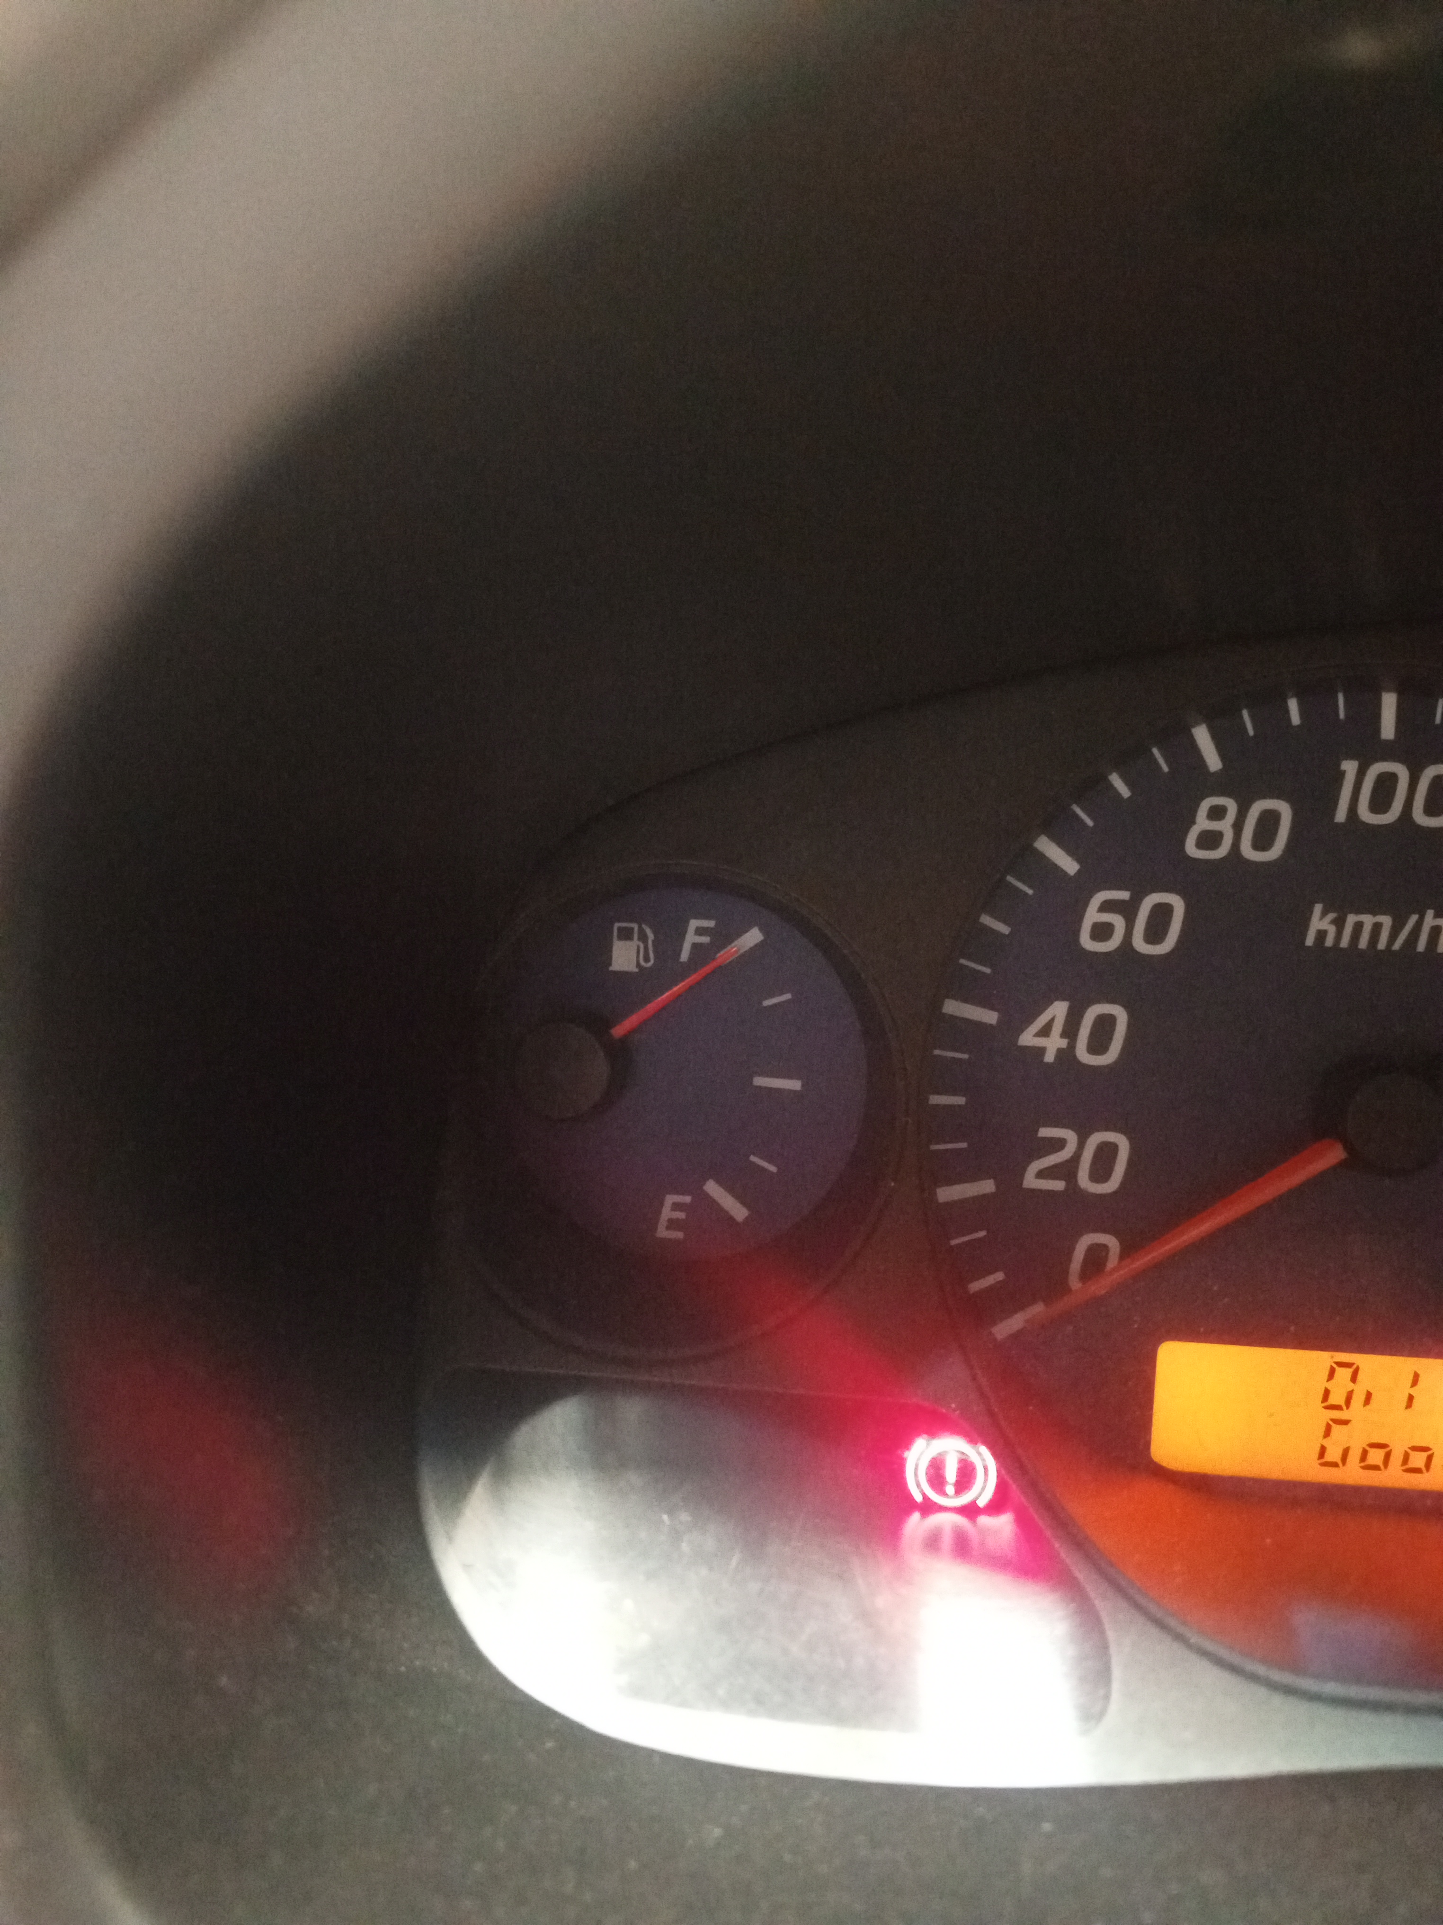

17252877989201236925878227327019.jpg

2024/09/02 Hora 09:57

2024/09/02 Hora 09:57

Nivel_del_combustible

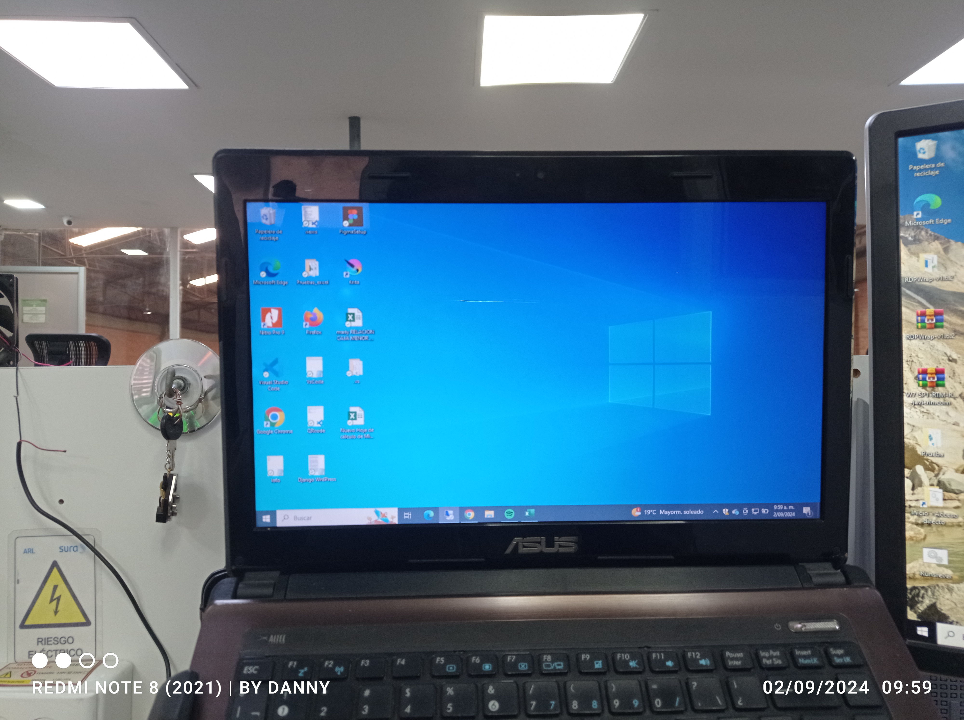

1725289187824863940344533368620.jpg

2024/09/11 Hora 17:25

Nivel_del_combustible

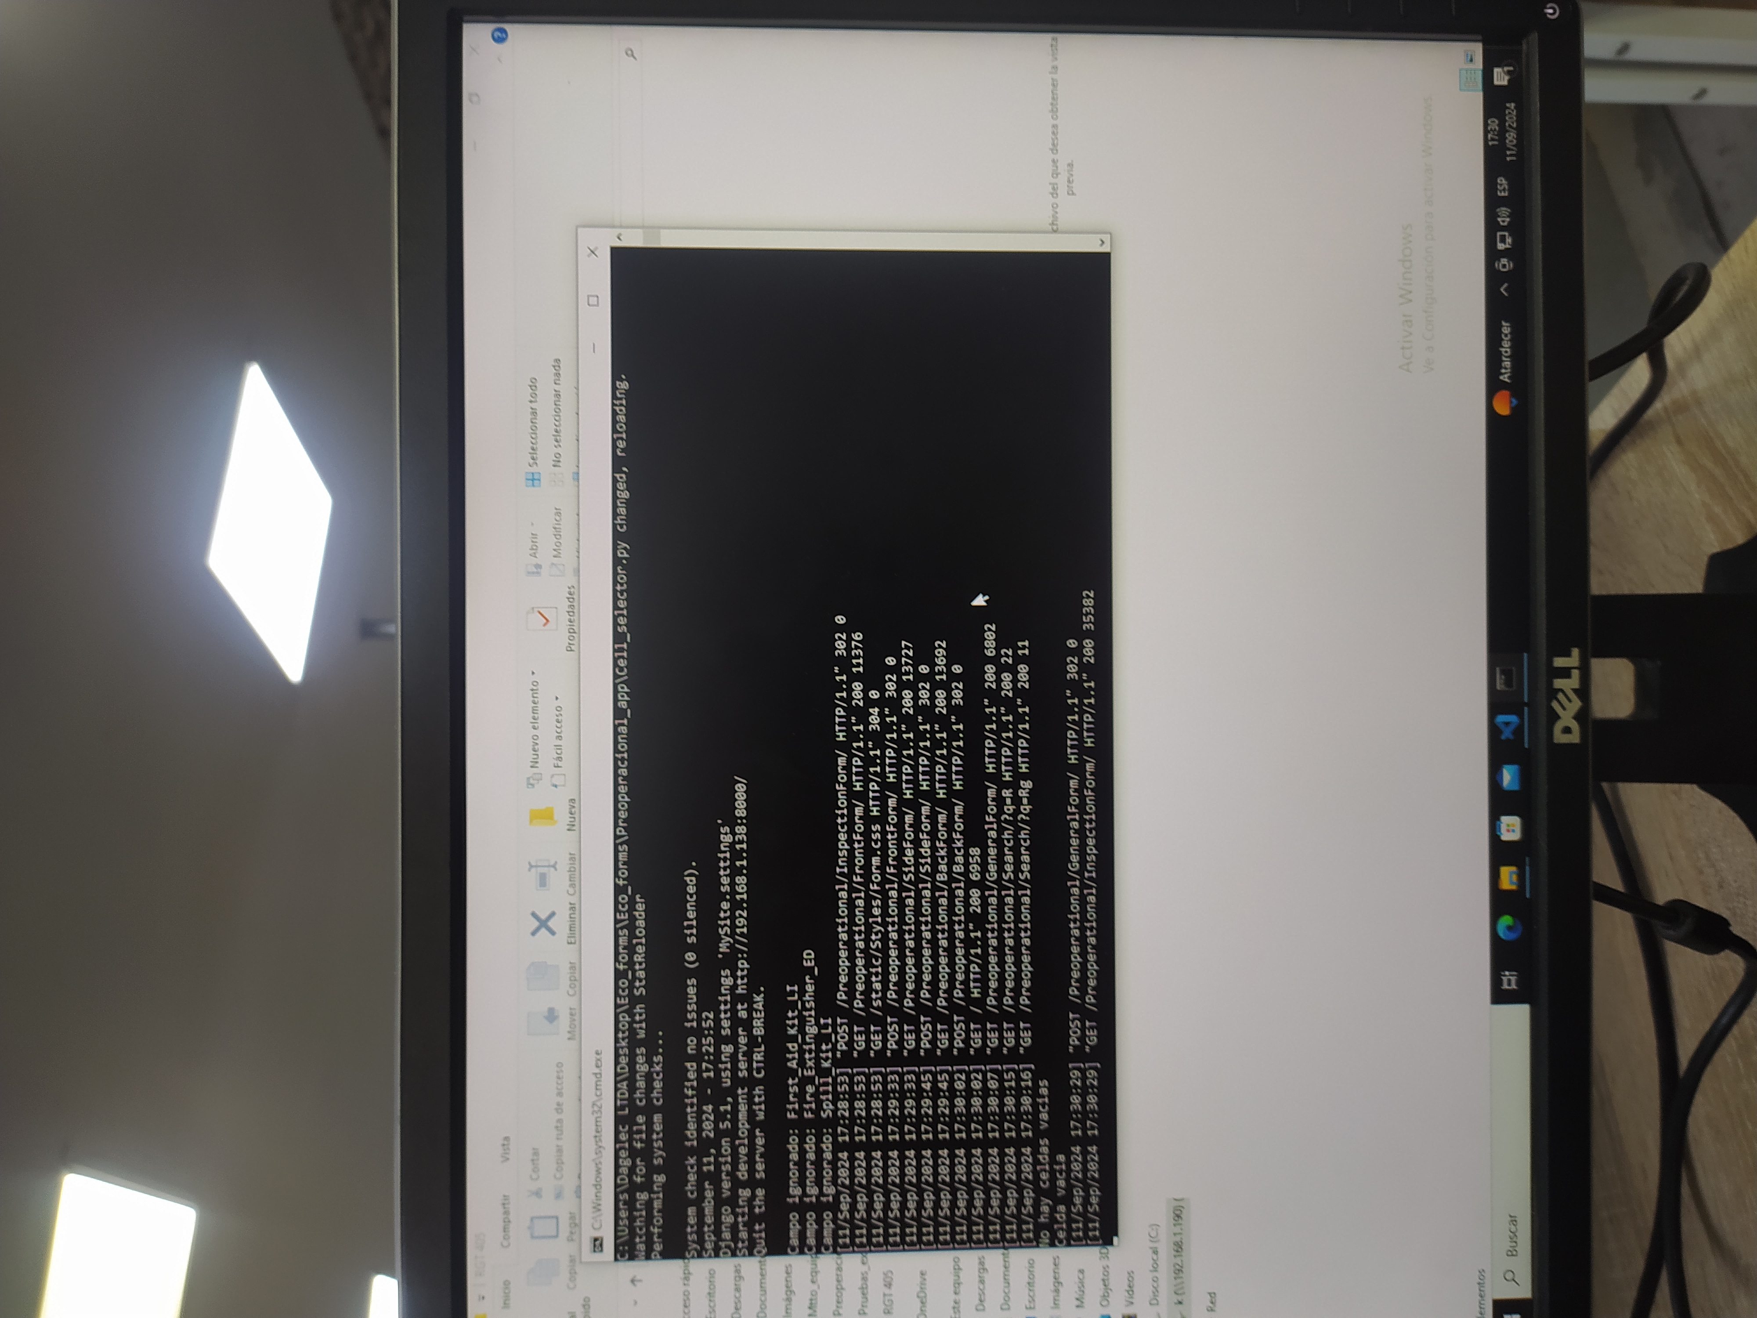

17260938464467850508201730479217.jpg

2024/09/11 Hora 17:25

2024/09/12 Hora 07:06

Nivel_del_combustible

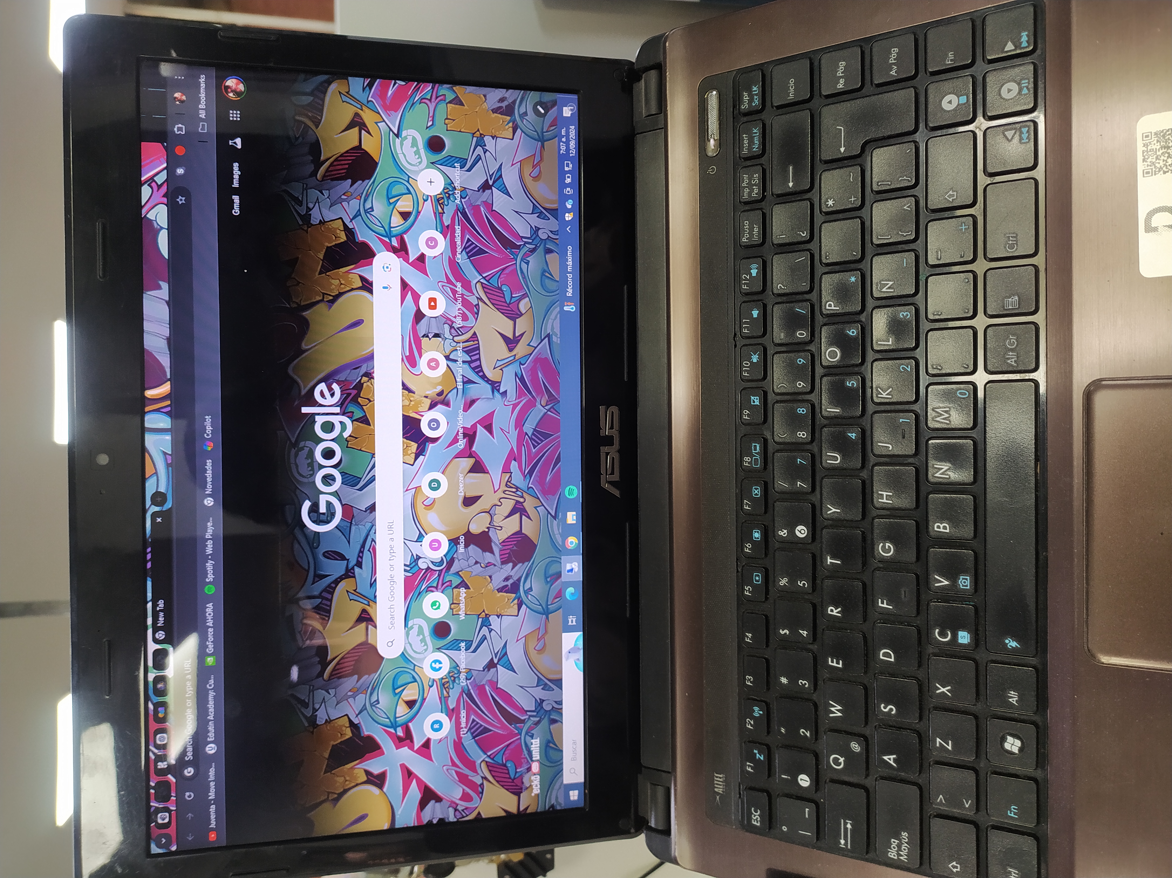

1726142866867585998123441852740.jpg

2024/09/12 Hora 09:16

2024/09/12 Hora 09:16

Nivel_del_combustible

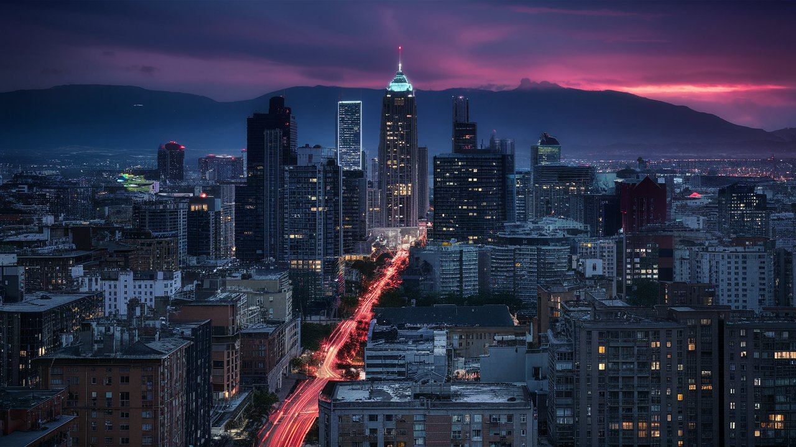

Generic background.jpeg

2024/09/16 Hora 09:34

Nivel_del_combustible

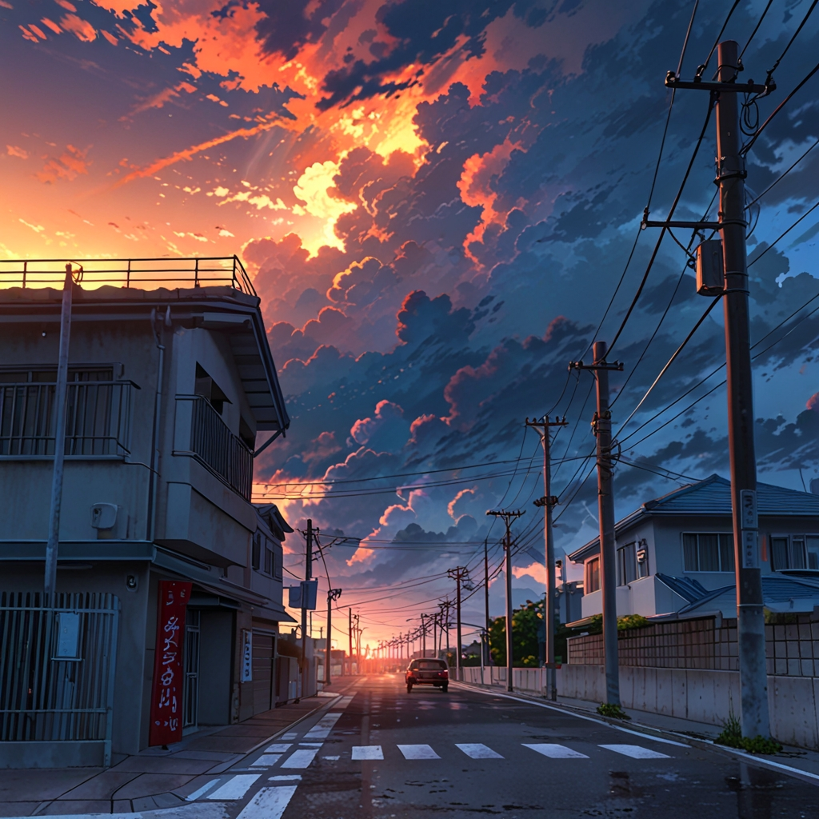

Default_Realizame_un_ecenario_de_una_ciudad_en_medio_de_unna_t_2.jpg

2024/09/16 Hora 14:43

2024/09/17 Hora 07:31

2024/09/17 Hora 07:37

2024/09/17 Hora 07:37